Lesson Set 11 | Introduction to C++  Structures
Purpose | - Understand the purpose and usage Structures.  - Awareness of structure with syntax and rules.  - Declaration and accessing elements of a structure.
Procedure | - Students should read the Pre-lab Reading Assignment before coming to lab.  - Students should complete the Pre-lab Writing Assignment before coming to lab.  - In the lab, students should complete Labs 11.1 through 11.2 in sequence.  - Your instructor will give further instructions as to grading and completion of the lab.  - Students should complete the set of lab tasks before the next lab and get them checked by their lab instructor.
 | Contents | Pre-requisites | Completion Time | Page Number
 | Pre-lab Reading Assignment | - | 20 min
 | Pre-lab Writing Assignment | Pre-lab Reading | 11 min
 | Lab 11
 | Lab 11.1  Working with structures | Understanding the structures | 30 min
 | Lab 11.2  Working with declaring and accessing the elements | Implementing the structures | 30 min

Pre-lab Reading Assignment

What is Structure | Structure is a collection of variables of different data types under a single name. It is similar to a class in that, both hold a collection of data of different data types.  For example: You want to store some information about a person: his/her name, citizenship number, and salary. You can easily create different variables name, cityNo, and salary to store this information separately.  However, in the future, you would want to store information about multiple persons. Now, you'd need to create different variables for each information per person: name1, citNo1, salary1, name2, citNo2, salary2  You can easily visualize how big and messy the code would look. Also, since no relation between the variables (information) would exist, it's going to be a daunting task.  A better approach will be to have a collection of all related information under a single name Person, and use it for every person. Now, the code looks much cleaner, readable, and efficient as well.  This collection of all related information under a single name Person is a structure.
Declare Structure | The struct keyword defines a structure type followed by an identifier (name of the structure).  Then inside the curly braces, you can declare one or more members (declare variables inside curly braces) of that structure.  For example:  struct Person  {  char name[50];  int age;  float salary;  };  Here a structure person is defined which has three members: name, age, and salary.  When a structure is created, no memory is allocated. The structure definition is only the blueprint for the creating of variables. You can imagine it as a datatype. When you define an integer as below:  int foo;  The int specifies that, variable foo can hold integer element only. Similarly, structure definition only specifies that, what property a structure variable holds when it is defined.  Note: Remember to end the declaration with a semicolon (;)
Define structure variables | Once you declare a structure person as above. You can define a structure variable as:  Person bill;  Here, a structure variable bill is defined which is of type structure Person.  When structure variable is defined, only then the required memory is allocated by the compiler.  Considering you have either 32-bit or 64-bit system, the memory of float is 4 bytes, memory of int is 4 bytes and memory of char is 1 byte.  Hence, 58 bytes of memory is allocated for structure variable bill.
Access structure members | The members of structure variable are accessed using a dot (.) operator. Suppose you want to access age of structure variable bill and assign it 50 to it. You can perform this task by using following code below:  bill.age = 50;

Example | C++ Program to assign data to members of a structure variable and display it.  #include <iostream>  using namespace std;  struct Person  {  char name[50];  int age;  float salary;  };  int main()  {  Person p1;  cout << "Enter Full name: ";  cin.get(p1.name, 50);  cout << "Enter age: ";  cin >> p1.age;  cout << "Enter salary: ";  cin >> p1.salary;  cout << "\nDisplaying Information." << endl;  cout << "Name: " << p1.name << endl;  cout <<"Age: " << p1.age << endl;  cout << "Salary: " << p1.salary;  return 0;  }  Output  Enter Full name: Magdalena Dankova  Enter age: 27  Enter salary: 1024.4  Displaying Information.  Name: Magdalena Dankova  Age: 27  Salary: 1024.4  Here a structure Person is declared which has three members name, age, and salary.  Inside main () function, a structure variable p1 is defined. Then, the user is asked to enter information and data entered by user is displayed.
Arrays of Structure | In C++, an array of structure is an array data type that is used to store a collection of structures of the same type. Each element of the array is a structure that contains one or more members, such as variables, arrays, or other structures.  Here is an example of how to define and use an array of structure in C++:  #include <iostream>  using namespace std;  struct student {  string name;  int age;  double gpa;  };  // Function that takes an array of structures as a parameter  void printStudents(student students[], int size) {  for (int i = 0; i < size; i++) {  cout << "Name: " << students[i].name << endl;  cout << "Age: " << students[i].age << endl;  cout << "GPA: " << students[i].gpa << endl;  }  }  int main() {  // Define an array of structures  student students[3];  // Assign values to the members of each structure in the array  students[0].name = "John";  students[0].age = 20;  students[0].gpa = 3.5;  students[1].name = "Mary";  students[1].age = 19;  students[1].gpa = 3.7;  students[2].name = "Bob";  students[2].age = 21;  students[2].gpa = 3.2;  // Call the function to print the values of the array  printStudents(students, 3);  return 0;  }  In this example, a function called printStudents is defined that takes two parameters: an array of student structures and the size of the array. The function uses a for loop to print the values of the members of each structure in the array.  In the main function, an array of student structures is defined and assigned values. The printStudents function is called with the array of structures and its size as arguments.  When calling the function, you only need to pass the name of the array variable and its size. Note that when an array is passed to a function, it is passed by reference. This means that any changes made to the array inside the function will affect the original array in the calling function.

Pre-lab writing assignment
Fill in the blanks | - A structure in C++ is a collection of related variables of different data types, grouped under a single name. These variables are called Members of the structure.  - To create a structure in C++, you use the keyword struct, followed by the name of the structure and the members of the structure, surrounded by curly braces.  - To access a member of a structure in C++, you use the dot operator (.). For example, if s is a structure and x is a member of that structure, you can access x with s.x.  - To initialize a structure in C++, you can use curly braces to specify the values of its members. For example: struct student{  String name;  Int age;  Int cms  };.  - To declare a variable of a structure type in C++, you use the name of the structure followed by the variable name. For example: structure Name;.

Lab 11
Lab 11.1 | Once you have opened the visual studio copy the following code in the code editor, try to run the code and observe the output. Write down the output that appears on the screen in the space given below  #include <iostream>  #include <string>  struct Student {  std::string name;  int roll;  int marks[3];  };  int main() {  Student students[5];  // Input student information  for (int i = 0; i < 5; i++) {  std::cout << "Enter the information for student " << i + 1 << ": " << std::endl;  std::cout << "Name: ";  std::cin >> students[i].name;  std::cout << "Roll number: ";  std::cin >> students[i].roll;  for (int j = 0; j < 3; j++) {  std::cout << "Marks in subject " << j + 1 << ": ";  std::cin >> students[i].marks[j];  }  }  // Find student with highest marks  int max_index = 0;  int max_marks = 0;  for (int i = 0; i < 5; i++) {  int total_marks = 0;  for (int j = 0; j < 3; j++) {  total_marks += students[i].marks[j];  }  if (total_marks > max_marks) {  max_marks = total_marks;  max_index = i;  }  }  // Display the information of the student with the highest marks  std::cout << "The student with the highest marks is: " << std::endl;  std::cout << "Name: " << students[max_index].name << std::endl;  std::cout << "Roll number: " << students[max_index].roll << std::endl;  std::cout << "Marks in three subjects: ";  for (int j = 0; j < 3; j++) {  std::cout << students[max_index].marks[j] << " ";  }  std::cout << std::endl;  return 0;  }  Enter the information for student 1:  Name: taha  Roll number: 1  Marks in subject 1: 50  Marks in subject 2: 50  Marks in subject 3: 50  Enter the information for student 2:  Name: ali  Roll number: 2  Marks in subject 1: 45  Marks in subject 2: 45  Marks in subject 3: 45  Enter the information for student 3:  Name: amir  Roll number: 3  Marks in subject 1: 40  Marks in subject 2: 40  Marks in subject 3: 40  Enter the information for student 4:  Name: asim  Roll number: 4  Marks in subject 1: 35  Marks in subject 2: 35  Marks in subject 3: 35  Enter the information for student 5:  Name: umair  Roll number: 5  Marks in subject 1: 30  Marks in subject 2: 30  Marks in subject 3: 30  The student with the highest marks is:  Name: taha  Roll number: 1  Marks in three subjects: 50 50 50
Lab 11.2 | Create a new project with new file with name lab9_2.cpp extension, copy the following code it and try to fill the missing code of the program. Observe the output that appears and write it in the box given below  #include<iostream>  struct dist  {  int feet;  int inch;  };  struct dist add(struct dist a, struct dist b)  {  struct dist d;  d.feet = a.feet+b.feet;  if((a.inch+b.inch0 >= 11)  {  d.feet = d.feet+((a.inch+b.inch)/11);  d.inch = (a.inch+b.inch)-(((a.inch+b.inch)/11)*11);  }  else  {  d.inch = a.inch+b.inch;  }  return d;  }  int main()  {  struct dist d1 = {11,2};  struct dist d2 = {14,11};  struct dist d = add(d1,d2);  cout << d.feet << " feet and " << d.inch << " inch" << endl;  return 0;  }  PS F:\Programming Fundamental\Labs\Lab 11> g++ test.cpp  PS F:\Programming Fundamental\Labs\Lab 11> .\a.exe  26 feet and 1 inch
Lab 11.3 | Create a new project with name lab9_3.cpp extension, copy the following code it and try to run the program. Observe the output that appears and write it in the box given below  #include<iostream>  struct complex  {  int real;  int imag;  };  struct complex add(struct complex a, struct complex b)  {  struct complex d;  d.real = a.real+b.real;  d.imag = a.imag+b.imag;  return d;  }  struct complex sub(struct complex a, struct complex b)  {  struct complex d;  d.real = a.real-b.real;  d.imag = a.imag-b.imag;  return d;  }  struct complex multiply(struct complex a, struct complex b)  {  struct complex d;  d.real = (a.real*b.real)-(a.imag*b.imag);  d.imag = (a.real*b.imag)+(a.imag*b.real);  return d;  }  int main()  {  struct complex d1 = {11,2};  struct complex d2 = {14,11};  struct complex d = add(d1,d2);  struct complex e = sub(d1,d2);  struct complex f = multiply(d1,d2);  cout << "ADD - " << d.real << "+" << d.imag << "i\n";  cout << "SUB - " << e.real << "+" << e.imag << "i\n";  cout << "MUL - " << f.real << "+" << f.imag << "i\n";  return 0;  }  ADD - 25+13i  SUB - -3+-9i  MUL - 132+149i

Lab 11 | Lab Tasks

- Create a structure called "Student" that stores the following information about a student: name (string), age (int), and grade (float). Then write a program that creates a Student object and initializes its values.

#include<iostream>
#include<string>
using namespace std;
struct Student
{
string name;
int age;
int grades;
};

int main()
{
Student Taha;
cout<<"Enter the Name of the Studnet : ";
cin>>Taha.name;
cout<<"Enter the Age of the Studnet : ";
cin>>Taha.age;
cout<<"Enter the Grades of the Studnet : ";
cin>>Taha.grades;
cout<<endl<<endl;
cout<<"The above given detailed of the student is as below: --"<<endl;
cout<<Taha.name<<" "<<Taha.age<<" "<<Taha.grades;
return 0;
}
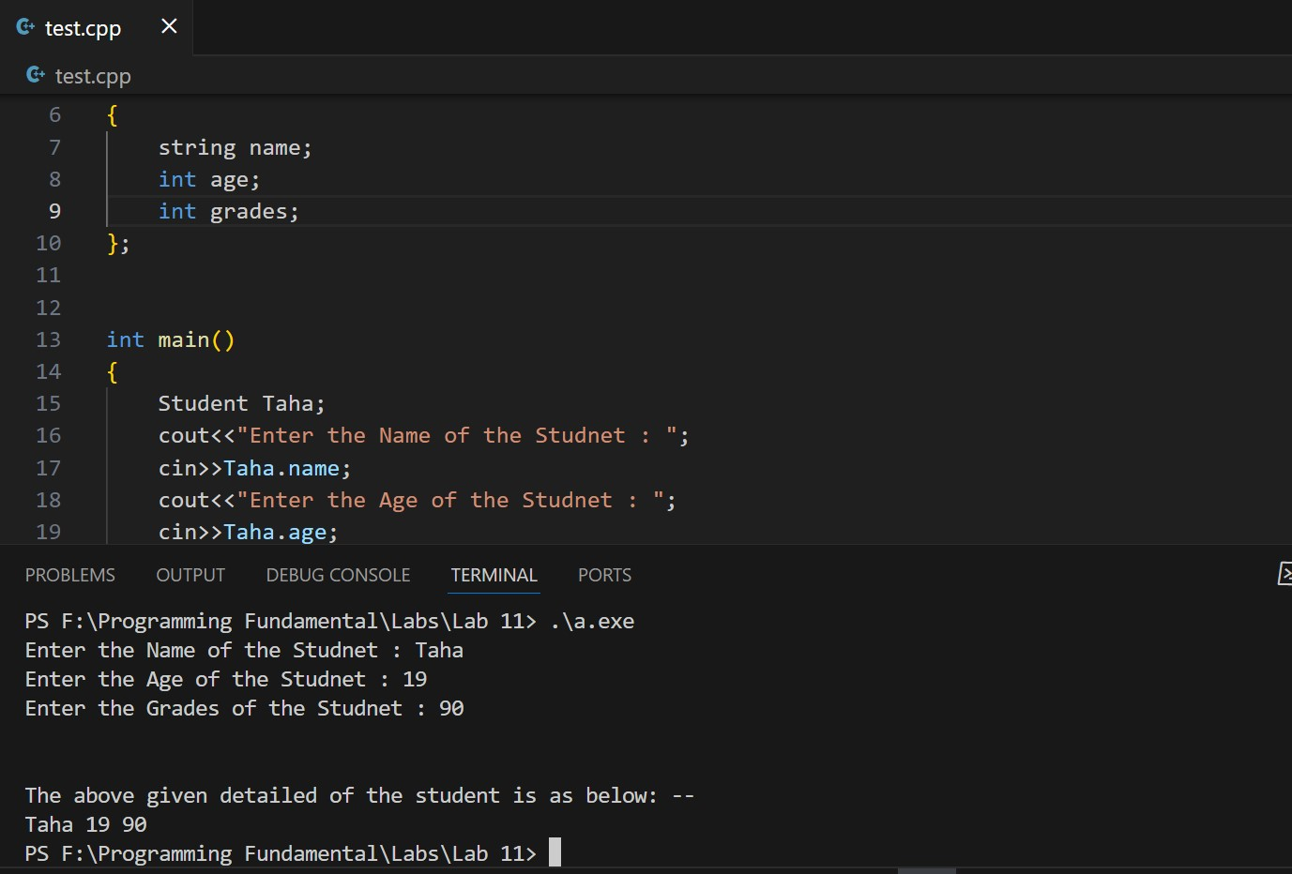

- Modify the program from question 1 to print the values of the Student object on the screen.

#include<iostream>
#include<string>
using namespace std;
struct Student
{
string name;
int age;
int grades;
};

int main()
{
Student Taha;
cout<<"Enter the Name of the Studnet : ";
cin>>Taha.name;
cout<<"Enter the Age of the Studnet : ";
cin>>Taha.age;
cout<<"Enter the Grades of the Studnet : ";
cin>>Taha.grades;
cout<<endl<<endl;
cout<<"The above given detailed of the student is as below: --"<<endl;
cout<<Taha.name<<" "<<Taha.age<<" "<<Taha.grades;
return 0;
}
OUTPUT:

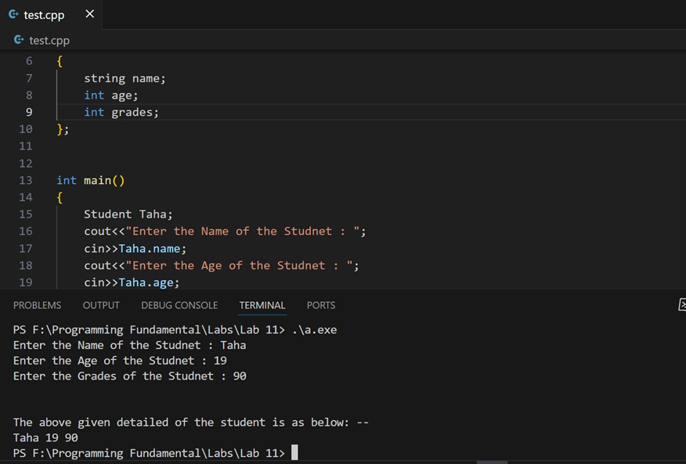

- Write a program that creates an array of 10 Student objects and initializes their values. Then, the program should print the values of all the students.

#include<iostream>
#include<string>
using namespace std;

struct Student{
string name;
int age;
char grade;
};

int main()
{
int i;
Student student[10];
for(int i = 0; i < 10; i++ )
{
cout<<"Enter the Name of the Student"<< i+1<< ":" ;
cin>>student[i].name;
cout<<"Enter the Age of the Student"<< i+1 <<":";
cin>>student[i].age;
cout<<"Enter the Grades of the Student"<< i+1 <<":";
cin>>student[i].grade;
}
cout<<endl<<"The Details of Students are as follow:---"<<endl<<endl;
cout<<"Name_"<<" "<<"Age_"<<" "<<"Grade_"<<endl<<endl;

for(int i = 0; i < 10; i++)
{
cout<<student[i].name<<" "<<student[i].age<<" "<<student[i].grade;
cout<<endl;
}
return 0;
}

- Write a program that creates a structure called "Course" that stores the following information about a course: course code (string), course name (string), and number of students (int). The program should then create an array of 5 Course objects and initialize their values. Finally, the program should print the values of all the courses.

#include <iostream>
#include <string>
using namespace std;

struct course
{
string courseCode;
string courseName;
int noOfStudent;
};

int main()
{
course Course[5];
cout<<"Enter the Details of the Course:----"<<endl;
for(int i = 0; i < 5; i++){
cout<<"Enter Code of course"<<i+1<<":";
cin>>Course[i].courseCode;
cout<<"Enter Name of course"<<i+1<<":";
cin>>Course[i].courseCode;
cout<<"Enter the Number of Student in the cousre"<<i+1<<":";
cin>>Course[i].noOfStudent;
}

cout<<"The Details of the course is as given below:-----"<<endl<<endl;
for(int i = 0 ; i < 5; i++){
cout<<Course[i].courseCode<<" "<<Course[i].courseCode<<" "<<Course[i].noOfStudent;
}
return 0;

}

